TABLE OF CONTENTS

CONTENT……………………………………………………………………………………………………PAGES
ABSTRACT………………………………………………………………………………………………………….2
INTRODUCTION…………………………………………………………………………………………………..3
PROBLEM DEFINITION ………………………..………………………………………………………………4
SOFTWARE DEVELOPMENT LIFE CYCLE (SDLC)………………………………………………………5
SYSTEM ARCHITECTURE DESIGN…………………………………………………………………………6
UML DIAGRAM……………………………………………………………………………………………………7
PROTOTYPE DEVELOPMENT - UI/UX DESIGN 8,9,10,11,12,13,14,15,16,17,18,19,20,21
GITHUB REPOSITORY & VERSION CONTROL …………………………………………………….…22
GANTT CHART ……..…………………………………………………………………………………………..23
NETWORK DIAGRAM ……….…………………………………………………………………………………24
LICENSE, DESIGN QUALITY & SDG RELEVANCE …….……………………………………………..25
CONCLUSION .……………………………………………………………………………………………………26
REFERENCES………………………………………………………………………………………………………27

ABSTRACT
Sierra Leone continues to face several barriers to equitable healthcare access, including a critical shortage of trained health workers, long travel distances to health facilities, and an uneven concentration of doctors in Freetown. This project presents MediLink SL, a Digital Public Good (DPG) designed to bridge this gap through a mobile and USSD-based telemedicine platform. MediLink SL enables patients to register, book appointments, undergo remote consultations with doctors via audio or video, receive e-prescriptions, and access basic system also supports Community Health Workers in rural areas by enabling referrals and facility-location services, and gives the Ministry of Healthy visibility into aggregated, anonymised health data for planning purpose.
Building on the initial Digital Public Good concept, this final project expands the design into a complete software engineering deliverable. The system is developed using the Incremental Software Development Life Cycle (SDLC) model, allowing iterative delivery of working modules, and its architecture follows a three-tier client-server pattern supported by RESTFUL APIs, an SMS/USSD gateway, and a relational database. A low/medium-fidelity prototype of eleven key screens was produced to represent the Figma-based UI/UX design, covering both the smartphone application and the USSD feature-phone journey. The project is structured for version control and collaboration on GitHub under an open-source licence consistent with Digital Public Goods Alliance principles, and is supported by a full project plan including a Gantt chart and a project network diagram.
Medilink SL is directly aligned with United Nations Sustainable Development Goal 3 (Good Health and Well-being) and contributes to Goals 9 and 10 by extending affordable, innovative digital infrastructure to under-served and rural communities.

INTRODUCTION
Access to timely and quality healthcare remains one of the most pressing development challenges facing Sierra Leone. The country’s health system was severely weakened by a decade-long civil war and the 2014 Ebola outbreak, and recovery has been slow and uneven across regions. Health professionals and specialized facilities remain heavily concentrated in Freetown and other urban centers, while rural districts continue to operate with a fraction of the required workforce. Achieving Universal Health Coverage requires a skilled health-worker-to- population ratio of about 44.5 per 10,000 people; Sierra Leone’s current ration is estimated at roughly 6.4 per 10,000, one of the lowest in the world.
At the same time, Sierra Leone has experienced rapid growth in mobile connectivity. Mobile cellular connections now cover almost the entire population, yet active internet use remains low, at roughly one fifth of the population, and is concentrated in urban areas. This digital divide means that any technological solution intended to serve the whole population, and particularly rural communities, cannot rely on smartphone or internet access alone; it must also work over basic USSD and SMS channels that function on any mobile handset.
This Final Project builds on the earlier assignment, Design of a Digital of a Digital Public Good System, and expands that initial concept into a complete software design: a full Software Development Life Cycle (SDLC) plan, and a layered system architecture, UML modelling, a functional low-fidelity prototype, a structured project plan, and a defined open-source license. A Digital Public Good (DPG), as defined by the UN Secretary-General’s Roadmap for Digital Cooperation and stewarded by the Digital Public Goods Alliance, is an open-source software, open data, or open content solution that respects privacy, does no harm, and helps countries attain the Sustainable Development Goals.
Notably, the Government of Sierra Leone is itself a co-founder of the Digital Public Goods Alliance, underlining the strategic relevance of designing local, open digital solutions for national development. MediLink SL has been designed in that spirit: as an open, replicable telemedicine platform suited to the realities of connectivity, workforce distribution and public health needs in Sierra Leone.

REQUIREMENT
PROBLEM DEFINATION
BACKGROUND OF THE PROBLEM:
- Workforce shortage and uneven distribution: the majority of doctors and specialists practice in Freetown, leaving rural districts such as Koinadugu with only a small fraction of the medical staffing density found in the Western Area.

- Geographic and transport barriers: poor road infrastructure and high transport costs prevent many rural residents from reaching a health facility promptly, contributing to delay treatment and avoidable complications.

- Limited continuity of care: patients with chronic conditions or those recovering from treatment often have no convenient way to follow up with a provider, track medication schedules, or receive reminders between physical visits.

- Low internet penetration: with internet access reaching only around one fifth of the population, internet- only mobile health applications would exclude the majority of citizens, particularly in rural areas where usage in the single digits.

- Fragmented referral pathways: Community Health Workers and peripheral health units often lack a structured digital channel to refer patients upward to qualified doctors or to track the outcome of referral.

- Week data visibility for planning: the Ministry of Health Sanitation (MOHS) and district health teams often lack consolidated, timely data on consultation demand, common conditions, and facility usage to plan resources effectively.

The central design problem, therefore, is how can a single digital platform deliver remote medical consultation, triage, referral and health-records services to both smartphone users and feature-phone users in Sierra Leone, in a way that is affordable, low-bandwidth-tolerant, and aligned with national health and digital development priorities? MediLink SL is proposed as a direct response to this problem.

SOFTWARE DEVELOPMENT LIFE CYCLE (SDLC)
The development of MediLink SL follows the Incremental SDLC Model. This model was chosen because it allows for the iterative delivery of functional modules, ensuring that critical features ( like USSD triage) can be deployed while more complex features (like video consultation) are still in development.

SYSTEM ARCHITECTURE DESIGN
System Architecture Design MediLink SL is structured as a three-tier client-server system to ensure scalability, security, and multi-channel access.

Architecture Diagram
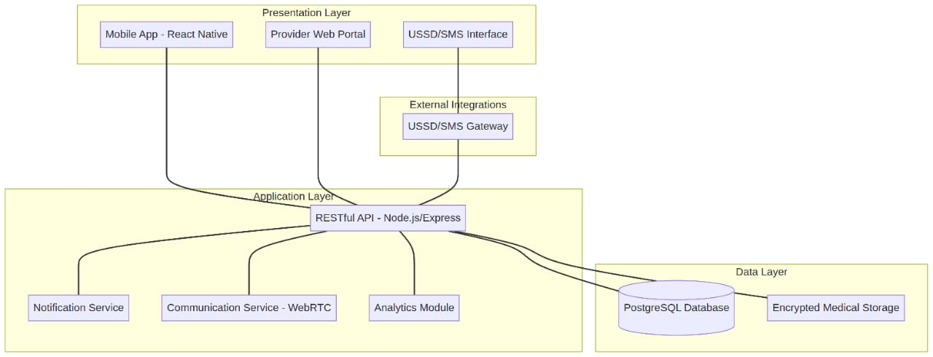

Component Interaction
- Presentation Layer: Users interact via a mobile app (react native), a web portal (for Doctors), or a USSD Interface.
- Application Layer: A RESTFUL APIs (Node.js/Express) handles business logic, while a Notification service manages SMS/Push alerts.
- Data Layer: A PostgreSQL Database stores patient records, while sensitive medical data is kept in Encrypted storage.
- Integration: The USSD Gateway (e.g., Africa’s Talking) translates numeric inputs into API calls, allowing feature phones to interact with the backend.

UML DIAGRAMS

MEDILINK SL TELEMEDICINE PLATFROM

The UML diagram below models the principal actors of MediLink SL and the functions each actors performs. Six diagrams interact with the system: Patients (smartphone users), rural patients who interact purely through USSD/Healthcare providers, Pharmacists, and a system Administrator.

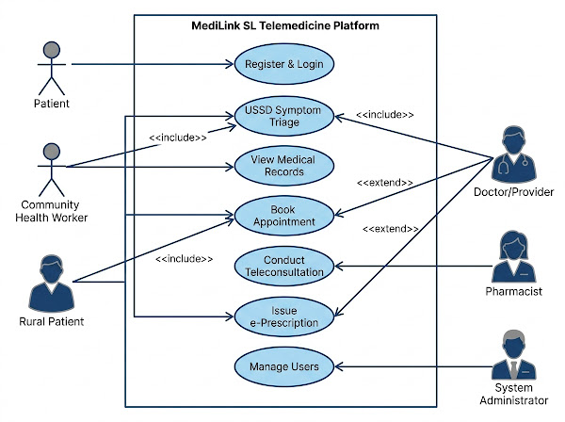

PROTOTYPE DEVELOPMENT – UI/UX DESIGN

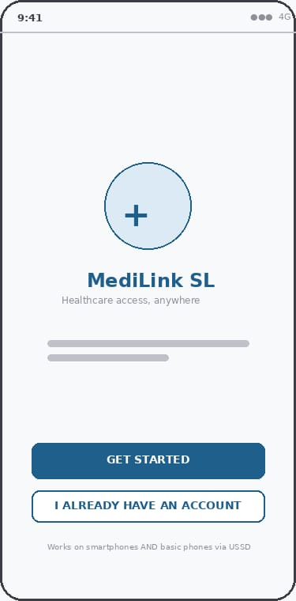
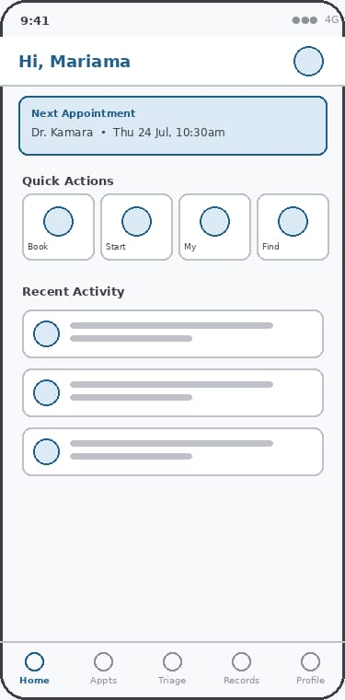

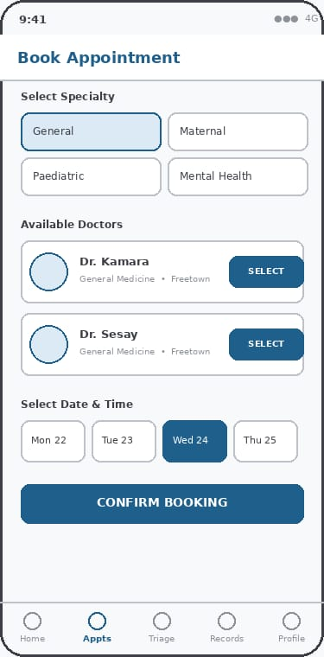

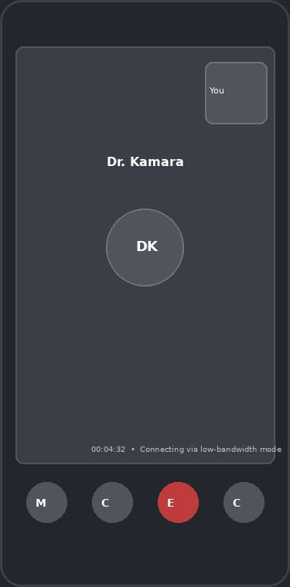

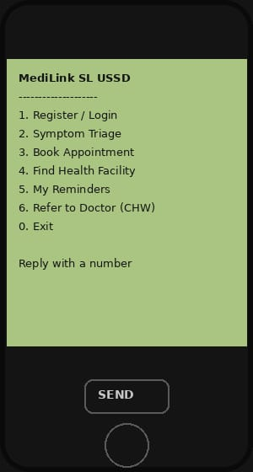

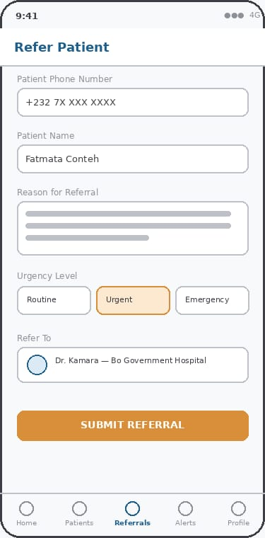

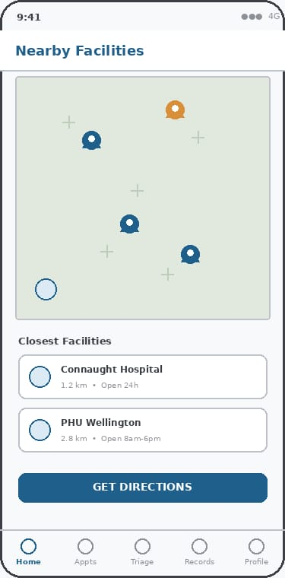

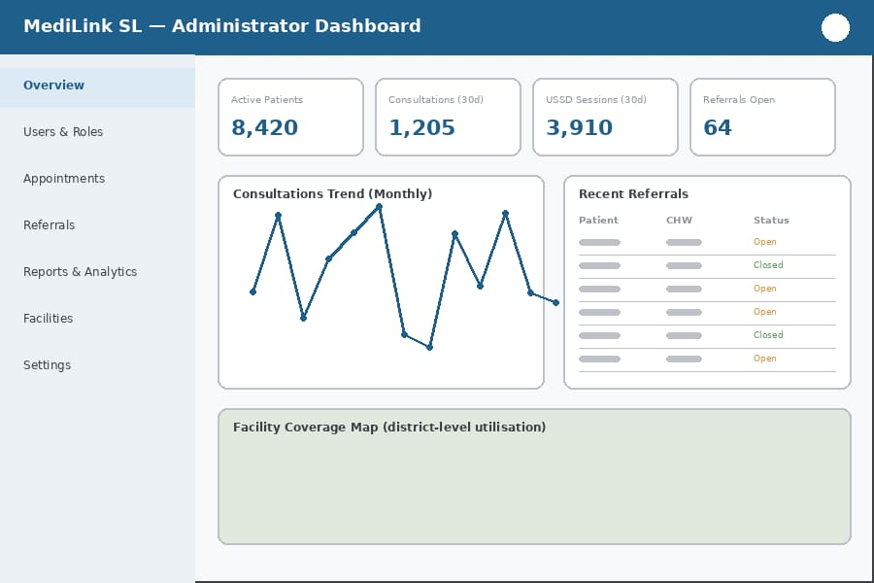

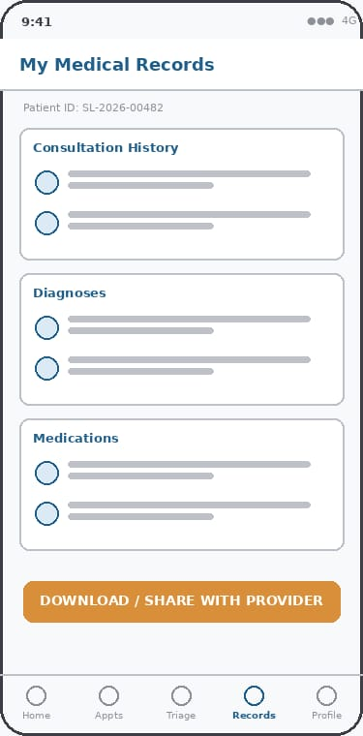

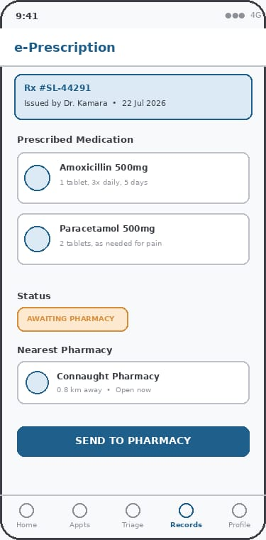

Description of Key Use Cases
- Register & Login (App/USSD): Allows patients, CHWs, and providers to create and access accounts; rural patients authenticate using a phone-number/PIN combination over USSD.
- Book Appointment: Patients select a provider/specialty and an available time slot for a consultation.
- USSD Symptom Triage & Advice: A menu-driven service that asks a structured set of questions and returns basic guidance or a referral recommendation, usable without internet access.
- Conduct Teleconsultation (Audio/Video): Enables a doctor and a patient to hold a remote consultation using the mobile app, where bandwidth permits.
- View/Update Medical Records: Lets patients view their history and lets doctors update diagnoses, notes and treatment plans.
- Issue/Fulfil e-Prescription: A doctor issues a digital prescription that a pharmacist can validate and fulfil.
- Locate Nearest Health Facility: Helps patients and CHWs find the closest operating peripheral health unit or hospital.
- Manage Health-Worker Referral: Allows a CHW to refer a patient to a doctor and track the referral status.
- Receive Appointment/Medication Reminder: Sends automated SMS/push reminders to patients.
- Generate Health Reports & Analytics: Produces anonymised, aggregated statistics for the Administrator and, by extension, the Ministry of Health.
- Manage Users & Platform: The Administrator's function for managing accounts, content and system configuration.

SYSTEM DESCRIPTION
MediLink SL is structured as a three-tier client–server system comprising a presentation layer, an application/business-logic layer, and a data layer, supplemented by an SMS/USSD gateway that extends the platform's reach to feature phones.
- Patient Mobile App: a cross-platform application (e.g., built with React Native) used by smartphone-owning patients to register, book appointments, join teleconsultations, and view records.
- Provider Web/Mobile Portal: used by doctors and pharmacists to manage schedules, conduct consultations, and issue or fulfil prescriptions.
- USSD/SMS Interface: a menu-based interface (e.g., via Africa's Talking or a similar telecom aggregator) used by patients without smartphones or reliable internet access for triage, appointment booking, and reminders.
- Administrator Dashboard: a web dashboard for platform management and reporting.
Application
- A RESTful API layer (e.g., built with Node.js/Express) that handles authentication, appointment scheduling, consultation session management, prescription workflows, and referral logic.
- A notification service that triggers SMS, push, and in-app reminders.
- A telehealth/communication service that manages audio/video sessions for consultations (e.g., using a WebRTC-based service such as Jitsi).
- A reporting/analytics module that aggregates anonymised usage and health-trend data.
Data Layer
- A relational database (e.g., PostgreSQL) storing patient profiles, appointments, prescriptions, referrals and facility data, secured according to data-protection best practice.
- Encrypted storage for sensitive medical information, with role-based access control distinguishing patients, CHWs, doctors, pharmacists and administrators.

Component Interaction
When a smartphone patient books an appointment, the mobile app calls the appointment API, which checks the doctor's availability in the database and creates a booking record. The notification service then sends a confirmation and a later reminder via SMS or push notification. For a rural patient using USSD, the same booking logic is invoked through the USSD gateway, which translates simple numeric menu choices into API calls, so that both channels share a single backend and database. During a teleconsultation, the application layer establishes a secure session token that the mobile app and the provider portal both use to connect via the video/audio service; consultation notes recorded by the doctor are written back to the patient's medical record through the API. Referral and prescription workflows follow a similar pattern: a CHW's referral, or a doctor's e-prescription, is created through the API, stored in the database, and made visible in real time to the next actor in the workflow (the receiving doctor or the dispensing pharmacist), with status updates flowing back to the originator. The Administrator dashboard and reporting module read aggregated, de-identified data from the same database to produce statistics useful to facility managers and, ultimately, the Ministry of Health.

GITHUB REPOSITORY & VERSION CONTROL
The project is hosted on GitHub to support open-source collaboration and version control. Repository Structure: /doctors : Reports, UML diagrams, and design specifications. /backend : Node.js API and database schemas.
/frontend : React Native mobile app and Web portal code. /USSD : USSD logic and gateway integration scripts.
Collaboration: Issues and Pull Requests are used to manage features and bug fixes.

PROJECT PLAN

The project is managed through a structured timeline and network dependencies.
Gantt Chart: The Gantt chart outlines the 5-month development cycle from planning to deployment.

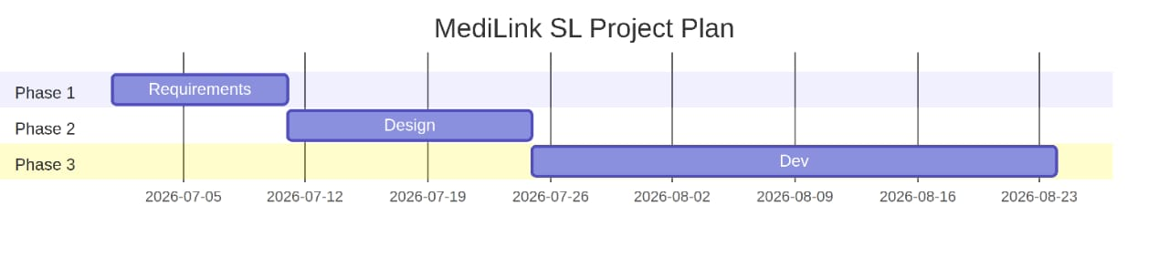

NETWORK DIAGRAM
The Network diagram (PERT CHART) shows the critical path and task dependencies.

LICENSE, DESIGN QUALITY & SDG RELEVANCE

LIcense MediLink SL is licensed under the MIT License, ensuring it remains a Digital Public Good that can be freely adopted, modified, and redistributed by other nations or NGOs.
Design Quality The UI/UX design follows WCAG 2.1 accessibility standards, ensuring high contrast for visibility and simplified navigation for users with low digital literacy.
SDG LINK
MediLink SL is primarily aligned with Sustainable Development Goal 3: Good Health and Well-being, which calls for ensuring healthy lives and promoting well-being for all at all ages. By enabling remote consultation, triage and medication reminders, the platform directly supports universal access to essential health services, particularly for populations in rural districts who are currently served by a fraction of the doctors available in the Western Area.
The project also supports SDG 9: Industry, Innovation and Infrastructure, by contributing an open, reusable digital infrastructure component that leverages existing mobile network coverage rather than requiring new physical infrastructure, and SDG 10: Reduced Inequalities, by deliberately designing for feature-phone and USSD access so that citizens without smartphones or reliable internet, who would otherwise be excluded from digital health services, are not left behind. As an open-source solution intended for adaptation by other public institutions, MediLink SL is also consistent with the wider mission of the Digital Public Goods Alliance, of which Sierra Leone is a founding member, to accelerate attainment of the SDGs through open, trustworthy digital tools.

CONCLUSION

MediLink SL demonstrates how principles of software engineering, including structured SDLC planning, layered system architecture, UML modelling and iterative prototyping, can be applied to design a realistic, locally relevant Digital Public Good. By combining a smartphone application with a USSD/SMS channel, the proposed system addresses the dual challenge facing health technology in Sierra Leone: a shortage of healthcare workers and a digital divide that limits internet-based solutions to a minority of the population. The system's architecture, use cases and prototype together show a feasible pathway toward improving healthcare access, continuity of care and health-data visibility, while its open licensing and GitHub-based development model support transparency, collaboration and long-term sustainability. With further development, piloting in partnership with the Ministry of Health Sanitation and district health teams, and refinement of the user interface based on field feedback, MediLink SL has the potential to make a measurable contribution to Sierra Leone's progress toward Sustainable Development Goal 3 and Universal Health Coverage.

REFERENCES

Digital Public Goods Alliance. (n.d.). Frequently Asked Questions. Retrieved from https://www.digitalpublicgoods.net/frequently-asked-questions
Digital Public Goods Alliance. (n.d.). What are digital public goods? Retrieved from https://www.digitalpublicgoods.net/
DataReportal. (2025). Digital 2025: Sierra Leone — Global Digital Insights. Retrieved from https://datareportal.com/reports/digital-2025-sierra-leone
Interoperable Europe Portal. (n.d.). Digital Public Goods Alliance. Retrieved from https://interoperable-europe.ec.europa.eu/collection/open-source-observatory-osor/digital-public-goods-alliance
Partners In Health. (2026). Sierra Leone. Retrieved from https://www.pih.org/country/sierra-leone
Pieterse, P., & Saracini, F. (2025). Improving Sierra Leone's skilled health-worker-to-population ratio: how unsalaried and auxiliary health workers are barriers in its path to universal health coverage. BMJ Global Health. https://doi.org/10.1136/bmjgh-2025-021043
Pressman, R. S., & Maxim, B. R. (2020). Software Engineering: A Practitioner's Approach (9th ed.). McGraw-Hill Education.
Sommerville, I. (2016). Software Engineering (10th ed.). Pearson Education.
United Nations. (2015). Sustainable Development Goal 3: Ensure healthy lives and promote well-being for all at all ages. Retrieved from https://sdgs.un.org/goals/goal3
United Nations Secretary-General's Roadmap for Digital Cooperation. (2020). Digital public goods. Retrieved from https://github.com/dpgalliance.

